Maratόn 10K Tuar Mhic Éadaigh 2013
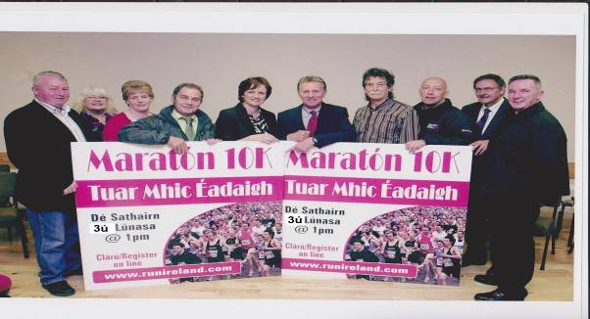
Tourmakeady 10K Mini-Marathon 2013 takes place on Saturday 3rd August. The route is along small
country roads, with scenic views of Lough Mask and the Partry mountains.
Beidh Fáilte mόr roimh gach duine Start time: 1pm from Tourmakeady Hall

Chip Timing for all entrants AAI approved (over 18 years only) €20 entry fee.

FREE T-SHIRT for first 125 entries

Register now on Run Ireland website (www.runireland.com) or in Tourmakeady Hall from 10.30am on the morning of race. Race number and chip collection on race day from 10.30am.
Water stations along the route. Suitable for runners, joggers and walkers
Beidh cupán tae ar fáil do gach duine ag deireadh an rás san Halla

Prizes for 1st, 2nd and 3rd in men and women categories
Funds raised go to the community Páirc Spraoí (recreational park) project.

Tourmakeady is a 60 minute drive from Galway city, 30 minutes from Connemara and 20 minutes from Castlebar, Westport and Ballinrobe. It is situated along the shores of Lough Mask adjacent to the Partry Mountains.

