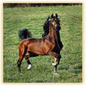
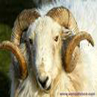

Tourmakeady Agricultural Show Society
Tourmakeady County Mayo

Declaration of Insurance

for Trade Stands, Stalls and other Commercial Exhibits

Name of Company and Individual and Nature of Stand:

Address: __________________________________________________________________

_________________________________________________________________

Tel No: _________________________________________________________________

Name of Insurance Company: ________________________________________________
Policy Number: ________________________________________________

Expiry Date: ________________________________________________

Please forward the completed form accompanied by the €50 fee and a copy of Insurance Policy to:-

Margaret Holmes, Tourmakeady Show Secretary, Drimcoggy, Srah, Claremorris County Mayo

Signed: _____________________________ Date: _______________________

