Tourmakeady Reunion Committee

Uimhreacha Teagmháil - Local Contacts

Cathy Mulroe 087-2157215

Sally Gibbons 094-9544082

Pádraig Ó hEanacháin 086-3599394

Ger Lydon 086-2354440

John Gibbons 087-2123527

Sean Kearns 086-3579100

Michael John Casey 087-6883624
email: kccabs@live.com

US Contact

Willie Barker 773-671-2730

Tá súil againn go bhfeicfidh muid sibh i dTuar Mhic Éadaigh i nGaeltacht Mhaigh Eo i Mí Iúil agus Lúnasa 2012.

Hope to meet you at the Tourmakeady Reunion in the
Mayo Gaeltacht in July August 2012.

21ú Iúil - 5ú Lúnasa
21st July-August 5th

Come and visit us in 2012 for two weeks of
Music, Sport, Craic and Activities for all ages and meet up with relatives and friends.

Beidh Céad Mile Fáilte romhat
féin agus do Chomhluadar!

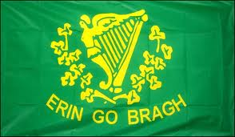

Calendar of events subject to change,
visit our website www.tourmakeady.com
for further updates.

Calendar of Events
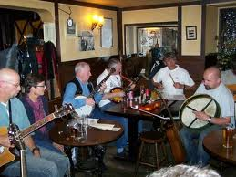
Saturday July 21st
Beat on the Street at O’Tooles

Sunday July 22nd
Tourmakeady Annual Agricultural Show
Session Mór in Máire Lukes

Monday July 23rd
Car Treasure Hunt 7 pm
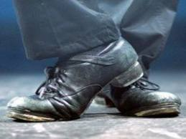
Sponsored by J.J Burkes Car Sales Ballinrobe.

Tuesday July 24th
Sean Nós Dancing 8pm

Wednesday July 25th
Cycle Race through Village 7 pm

Thursday July 26^{th-}
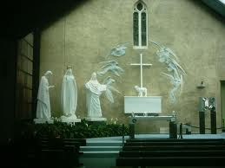
Parish Trip to Knock Shrine-Bus Arranged
Teenage Disco in Hall
Age 6-11 from 6-8pm
Age 12 upwards 9-11pm

Friday July 27th

Music at Máire Lukes with John Beag Ó Flatharta

Sunday July 29th
Walk in the grounds of Drimbawn House
& Tourmakeady Loop Walk at 3pm.
American Tea Party in Hall 9.30 pm

Calendar of Events

Monday July 30th
Card Making Workshop in the Hall 10.30-1 pm(Contact 087-9481196) 25 Card Game in O’Toole’s 9.30 pm

Tuesday July 31st
Card Making Workshop in the Hall 10.30-1pm (Contact 087-9481196) Country & Western Concert at Máire Lukes with Nathan Carter

Wednesday August 1st
Golf Outing in Ballinrobe Golf Course
Golf Presentation Night in Lough Mask Inn at 9.30 pm

Thursday August 2nd
Hill Walking Day Out
Drámaíocht & Siamsaíocht san Halla 8.30 pm

Friday August 3rd
Churchfield Cemetery Mass at 6 pm
Reunion Dinner Dance in Paddy’s

Saturday August 4th
Mini Marathon at 1 pm. Register on www.runireland.com.
Céilí san Halla. Music by Annaly Céilí Band.

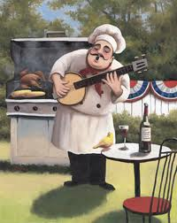
Sunday August 5th
Mass in Cemetery at 11.30 a.m. followed by Tea.

Emigrant Football Day 2 pm

Annual BBQ Night in the Lough Mask Inn

