HOLLY – Ilex aquifolium – Cuileann
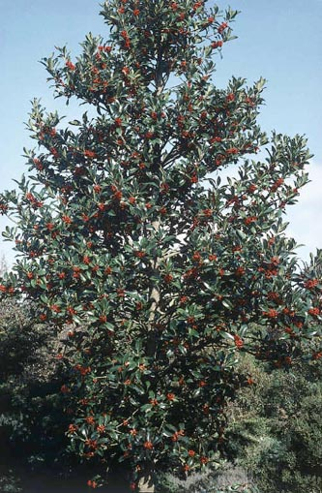 | 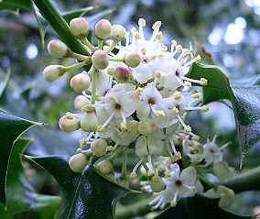  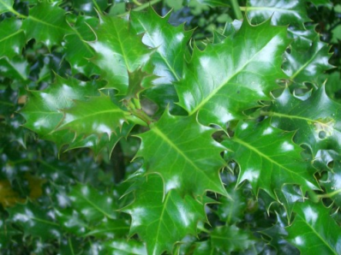
SESSILE OAK – Quercus petraea – Dair ghaelach

Description

This tree gets up to forty metres tall. There are several more types of oak trees in this forest, but they are all similar in many ways, especially in their leaf shape.

It has lobed leaves that are glossy and green on top and pale green and fuzzy on the underside.

It loses its leaves in the autumn.

It has grey bark with thin cracks in it.

Acorns grow on this tree.

Uses and Stories

The oak is a symbol of strength and endurance. • It has excellent, sturdy wood. • Its acorns provide food for many different types of animals. • Many names are related to the Irish for “oak” including Cill Dara or Kildare, and Daire Calgaich or Derry.
HOLLY – Ilex aquifolium – Cuileann

Description

This tree can get up to 14 metres in height.

Its leaves are dark green and have pointed edges.

It does not lose its leaves in the winter.

It has red berries for most of the year and tiny, white flowers with a very strong smell.

Uses and Stories

The holly is a symbol of protection, magical power, and purification. • It used to be used for making spears and chariot poles. • Holly is a crann uasal or noble tree in Ireland, and you annoy the fairies if you use it for an unworthy task.
LARCH – Larix decidua – Learóg
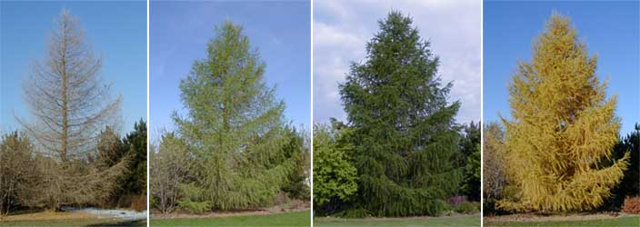 | 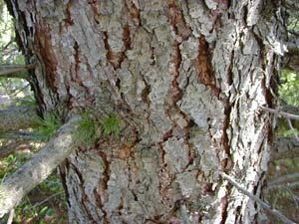  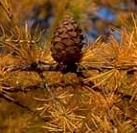  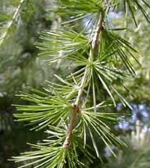
GORSE – Salix cinerea – Aiteann
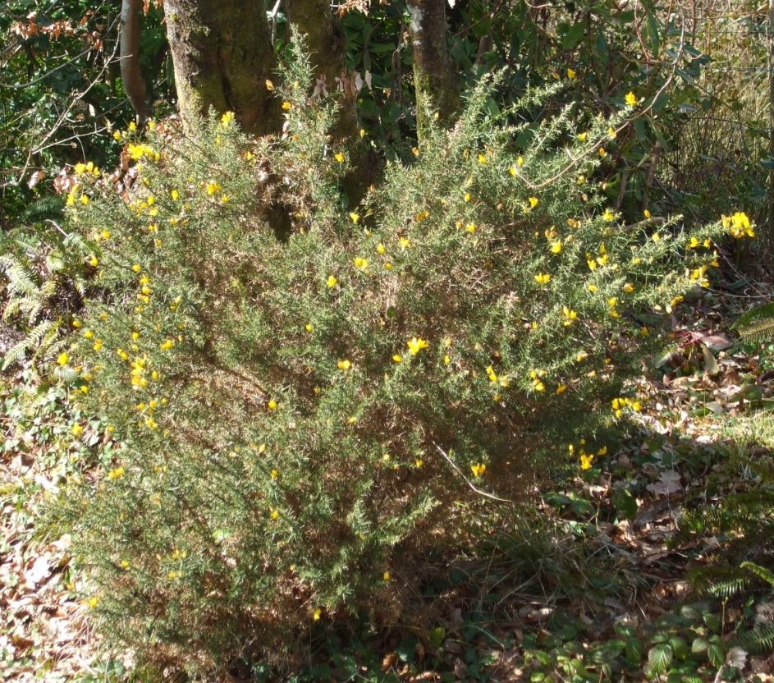 | 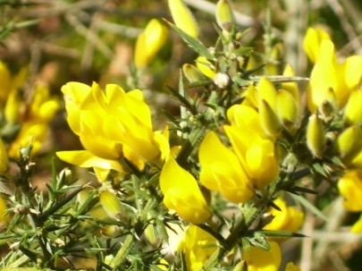
LARCH – Larix decidua - Learóg

Description

This tree can grow to be up to thirty-five metres tall.

Its needles are soft and pale green.

Its needles turn yellow and are shed every autumn.

Its bark is brownish-gray and cracked.

It has two kinds of cones. The male cones are whitish, turning yellow late in the season. The female cones are rosy-red.

Uses and Stories

The wood from larch trees is frequently planted by foresters. • Its wood is useful for fences, gates, and fishing boats.
GORSE – Salix cinerea – Aiteann

Description

Other names for this shrub include furze and whin. It can grow to be up to two metres tall.

It has blue-green leaves that are tiny scales or thorns.

It does not lose its leaves in the winter.

It has small yellow flowers and black seed pods.

Uses and Stories

Gorse is a symbol of wealth or the fertility of the land. • There is an old Irish saying that says, “An t-ór fé’n aiteann, an t-airgead fé’n luachair agus an gorta fé’n bhfraoch.” • Walking sticks were made from the wood of gorse. • Hedges were frequently made of gorse.

Name(s):_______________________________________________________ _______________________________________________________

Animal Food Search
Sometimes, it’s hard to find food! See how well you can do!

Circle the animal that you are pretending to be: rabbit crossbill badger

After looking at the animal field guide (which works just like a tree field guide), I know that this animal eats:________________________________________________________________________

Mark the number of times that you find this food as you walk along the trail. Tally marks work well for helping you count. Tally marks look like this:
1 | 2 | 3 | 4 | 5

After you get to five, you start over with another group. So, for example:
7  5 + 2 | 10  5 + 5

Try to use tally marks to keep track of how much food you find!
 | Tally Marks | Final Number
Number of times you found food

Name(s):_______________________________________________________ _______________________________________________________

Do People Have a Habitat?
People are animals, too. Since we know that all living things need a habitat, that must mean that people have a habitat! Fill in the table below with different things that people get from their environment.

FOOD  What do you eat that grows or can be found outdoors? | WATER  What are some different uses for water? | SHELTER  What do you find in your house that come from nature?

Background Information
Tourmakeady

Irish Language Connections
Tourmakeady is one of the Gaeltacht regions in County Mayo, meaning that the Irish language and culture is of special significance. Irish is the second-oldest vernacular language – it has been used in writing for over 1500 years. During the time of the English landlords, a great number of wealthy English-speakers moved into the region. The use of the Irish language was discouraged; it was considered “the poor person’s language” at that time. Now, however, the language is viewed as a significant part of Irish heritage, and its use is being encouraged in areas like Tourmakeady through the support of local community groups like the Coiste Pobail in Tourmakeady and Údarás na Gaeltachta.

Part of the area’s ties to the Irish language come from the presence of Coláiste Chonnacht. This was a school that was founded in 1905 by the Gaelic League. It was a summer college with the purpose of teaching National School educators Irish. Its courses were bilingual, and given that students came from around the county and around the world, accommodations were needed within the community. This tied the school to the local people who often had students living in their homes. In support of the students’ education, community members used Irish as frequently as possible and continued with many Irish customs to make the experience as authentic as possible. The school was very popular until the mid-1930s. At this stage, the area suffered severe economic difficulties and many families (especially Irish-speaking families) were forced to move in search of new opportunities. Eventually, the community support for the language disappeared, and it was decided in 1940 that there was not enough Irish spoken in the area to permit an Irish school to be located there. The school was closed and a knitwear factory moved into the building. Another local school, Coláiste Mhuire, was founded in 1927. This school still has strong ties to Catholicism and the Irish language, and is perceived as a secondary school that provides a very high quality education.

Evidence of the influence of the Irish language in Tourmakeady today can be seen in the placenames of the area. For example:

English Name | Irish Name | Translation from Irish
Ballybanaun Mountain | Baile Uí Bhánáin | “Ó Banáin’s townland”
Cappaghduff | An Cheapaigh Dhuibh | “the black tillage plot”
Carheen | An Caithrín | “the little stone fort”
Derrassa | Doire Easa | “thicket of the waterfall”
Derrassa Commons | Coimín Dhoire Easa | “commons of Doire Easa”
Derryveeny | Doire Mhianaigh | “thicket of the mine”
Drumcoggy Mountain | Droim Chagaigh | “ridge of the war”
Glenmask | Gleann Mheasca | “Measca’s valley”
Glennagashleeny | Gleann na gCaislíní | “the valley of the streamlets”
Gortbunacullin | Gort Bhun an Chuilinn | “the field of the bottom(-land) of the holly”
Gorteenmore | An Goirtín Mór | “the big field”
Gortfree | Gort Fraoigh | “field of heather”
Shangort | An Seanghort | “the old field”
Shanvallyard | An Seanbhaile Ard | “the high old townland”
Srah | An tSraith | “the strath (river holm)”
Tawnagh | An Tamhnaigh | “the (mountain) field”
Toormakeady | Tuar Mhic Éadaigh | “Mac Éadaigh’s pasture”
Treanlaur | An Trian Láir | “the middle third”
Glensaul River | Abhainn na Mallachtan / Abhainn Ghleann Sál | “the river of the curse(s)” / “river of the valley of the mountain spurs”
Inishdawaur | Inis Dá Bharr | “island of the two tops”
Lough Mask | Loch Measca | “Measca’s lake”

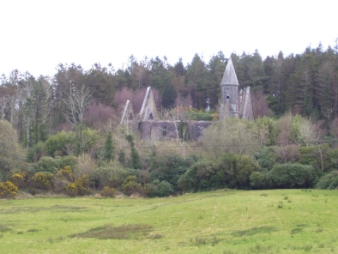
History
Old Protestant Church
When researching the history of Tourmakeady (Tuar Mhic Éadaigh), its history of landlordism plays a very prominent role. The local landlord family, the Plunkett family, came to Tourmakeady in 1831, and expanded their holdings over the next 20 years until they owned 10,000 acres of land. Several buildings were established by the family on this property including Tourmakeady Lodge, a fishing lodge, Drimbone Lodge along the lake, Partry Lodge, and Cappaduff Cottage. Cappaduff cottage was the home of Catherine Plunkett, the sister of Thomas Plunkett (the Protestant bishop of Tuam). Catherine was well-known for her proselytising. She was known as “Kate of the Soup” because, during famine times, she would feed any local people who were willing to convert to Protestantism. This led to the local term of “souper” in reference to anyone who converted from Catholicism. Catherine also started a Protestant school where she fed the students; the poverty and hunger of the times in combination with this offer resulted in many local people leaving the Catholic schools. The urge to leave the schools run by the Franciscan monks was reinforced by Plunkett’s eviction of families who attended Catholic mass and sent children to the Catholic schools. This led to major controversy between Plunkett and Fr. Lavelle, the local Catholic priest, who used the media as a tool to oust the Plunkett family. In the 1860s, due to pressure from abroad in response to the Plunketts’ treatment of the local people, the Plunketts moved to Tuam. Many landmarks remain in the area, keeping the memory of the Plunketts fresh with the local people; these include the Protestant Church and graveyard, the Tourmakeady Wood, and several of the old houses.

Another era of historical significance in Tourmakeady in the early 1920s. There was a strong Irish Republican Army base to the community, and it was not uncommon for local IRA members in the mountains of Tourmakeady to watch the Royal Irish Constabulary barracks across the lake in Ballinrobe for signs of action. When movement was seen at the RIC barracks, a bonfire was lit atop a hill in the Glensaul region to signal local members of the IRA of the pending. There continued to be conflict between the IRA and the RIC, the most famous of which was the Tourmakeady Ambush. In this conflict, the IRA attacked the RIC barrack in Tourmakeady, preventing the arrival of supplies from Ballinrobe. Five IRA members were killed in the Ambush, and it had the impact of scattering the IRA in the area for some time.

A third historical topic that is frequently mentioned with regard to the Tourmakeady area involves the Maamtrasna Murders. Many people are insensitive to the fact that this atrocity occurred within very recent history in this area, and that people who are still living might have had parents or grandparents involved in the events – it is widely perceived throughout Tourmakeady that “outsider

Tomas O’Toole
Fiachra Mac Gabhainn
www.tourmakeady.com, Tomas O’Toole
John McGurk

