RED SQUIRREL – Sciurus vulgaris – Iora rua  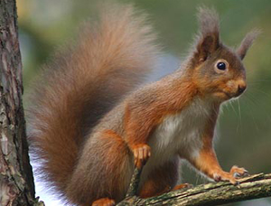  Description: Ireland’s only native squirrel species, this squirrel is orange-red and has ear tufts! It is found mostly in forests.  Diet: Cones, shoots of baby conifers, bark of conifers, berries, nuts, and seeds. | 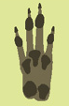  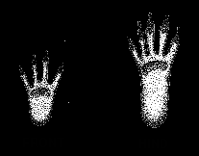 Front Hind
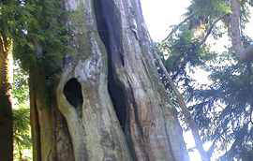

Description of shelter: In a hollow tree, a hole in a dry rocky
place, or the abandoned nest of a large bird or squirrel. Sometimes lined with grasses.

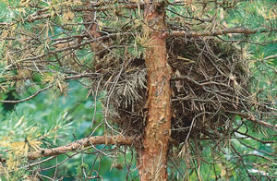

Description of shelter: Messy bundles of twigs lined with grasses,
located high in a tree.

Name __________________________
Using Field Guides – It’s a ____________________!
This sheet will help you figure out what tree or shrub you’re looking at!
Draw the basic shape of the tree, plant, or  shrub here! | Draw the leaf or flower that you’re looking at as best as you can – just a sketch!

Checklist for Trees/Plants Seen
Draw
Describe:
Tree? Shrub?

Check all of the boxes below that describe your tree or shrub.
Leaf
- It has needles.
- The leaf has a toothed edge. This means that there are pointy
parts coming out of the leaf. It might look kind of like this:
- The leaf has a smooth edge.
- The leaf has lobed edges. This means that the edge of the leaf is wavy.
It might look kind of like this.
- I can’t tell.
Bark

- Gray
- Brown
- White
- Red
- Flaky and papery
- Thick and rough

Colour of leaves

- Green
- Yellow
- Brown

Seed

- Acorn or another nut
- Pinecone
- I don’t know

Flowers – Describe the flowers here. Does it have them? What colour are they? How many petals? Are they big or little? Write down anything else you can about them!
- _____________________________________________________________________________________________________________________________________________________________________________________________________________________________________________

SILVER BIRCH – Betula pendula – Beith gheal
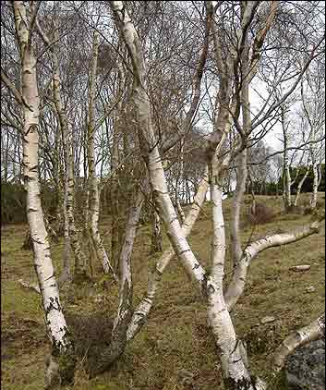 | 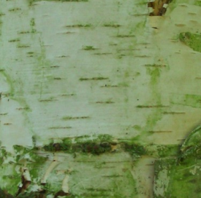  catkins →
BEECH – Fagus sylvatica – Feá
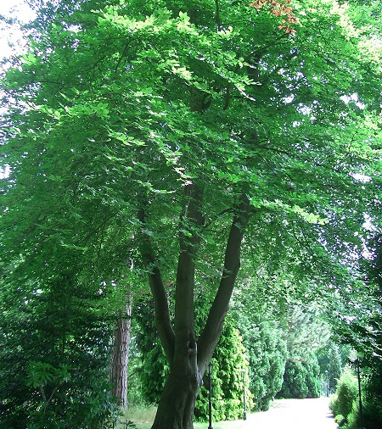 | 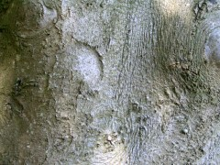  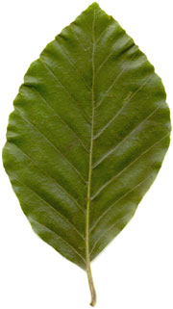
SILVER BIRCH – Betula pendula – Beith gheal

Description

This tree is very similar to its close relative, the Downy birch – even experts find it hard to tell the difference sometimes! It grows up to thirty metres tall.

Its leaves are about 2.5 – 7 cm in length, and they have very pointed teeth along the edges.

It loses its leaves in the late autumn.

Its bark is silvery-white or grey and peeling.

It has “catkins” (structures that hold flowers) that hang off the tips of its branches.

Uses and Stories

The twiggy branches of this tree were used as brooms. • Dye from birch bark was used for tanning leather and preserving fishing lines. • Birch is a symbol of love, and when given as a gift to a loved one, it was supposed to be a symbol of constancy. • Fairies are not supposed to like birch trees.
BEECH – Fagus sylvatica – Feá

Description

This tree can grow to be up to forty metres tall.

Its leaves are oval, smooth-edged, and about ten by six centimetres.

Its leaves turn yellow or red before falling in late autumn.

It has smooth silvery-grey bark.

Its fruits are triangular-shaped nuts with a spiny coating.

Uses and Stories

Beech wood was frequently used in England for furniture.

