SCOTS PINE – Pinus sylvestris – Péine albanach
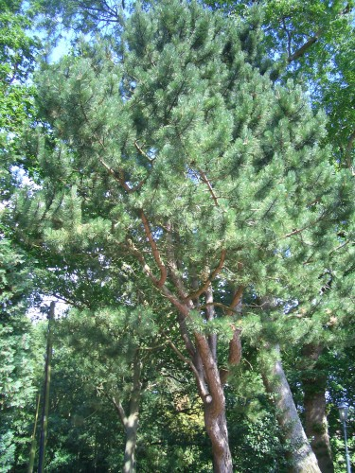 | 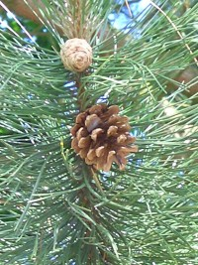
RHODODENDRON - Rhododendron ponticum – Róslabhras
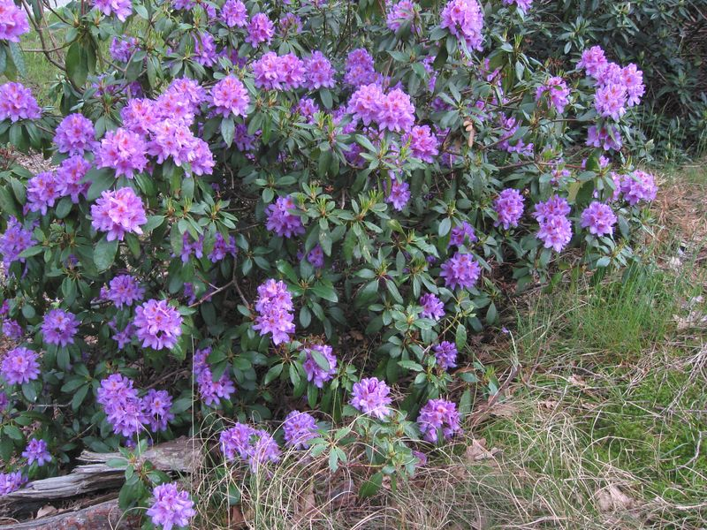 | 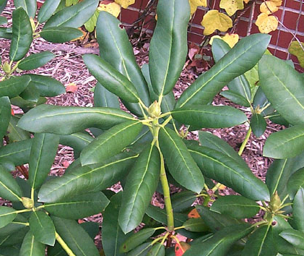
SCOTS PINE – Pinus sylvestris – Péine albanach

Description

When this tree has been growing for many years it has a flat top. It can grow to be up to 25 metres tall.

It has grey-green needles that are four to eight centimetres long.

It keeps its needles year-round.

It has chocolate-reddish bark that is cracked and flaking.

It has male cones that are very small and clustered, and female cones that are dark red and in groups of two to five.

Uses and Stories

The pine is a symbol of renewal, rebirth, and eternal life. • It has been used for centuries as a source of light when burned because of its bright white flame, especially pieces pulled from the bog.
RHODODENDRON - Rhododendron ponticum – Róslabhras

Description

This shrub is considered an “invasive species” in Ireland – it grows so well in this habitat that it is using up OTHER species’ habitats! It can grow to three metres in height.

It has dark green leaves with smooth edges. They are about twelve by six centimetres.

It keeps its leaves year round.

It has many large clusters of purple flowers.

Uses and Stories

Rhododendrons are native to the Himalayas, Turkey, and Spain. • It is planted in gardens and wooded areas as ground cover for pheasants.
SESSILE OAK – Quercus petraea – Dair ghaelach
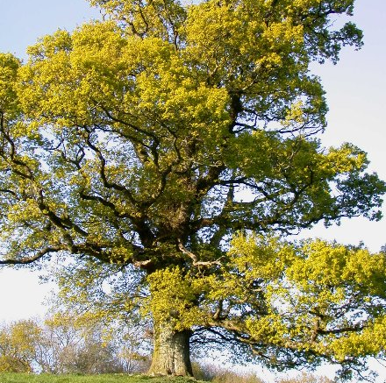 | 