Name:_______________________________

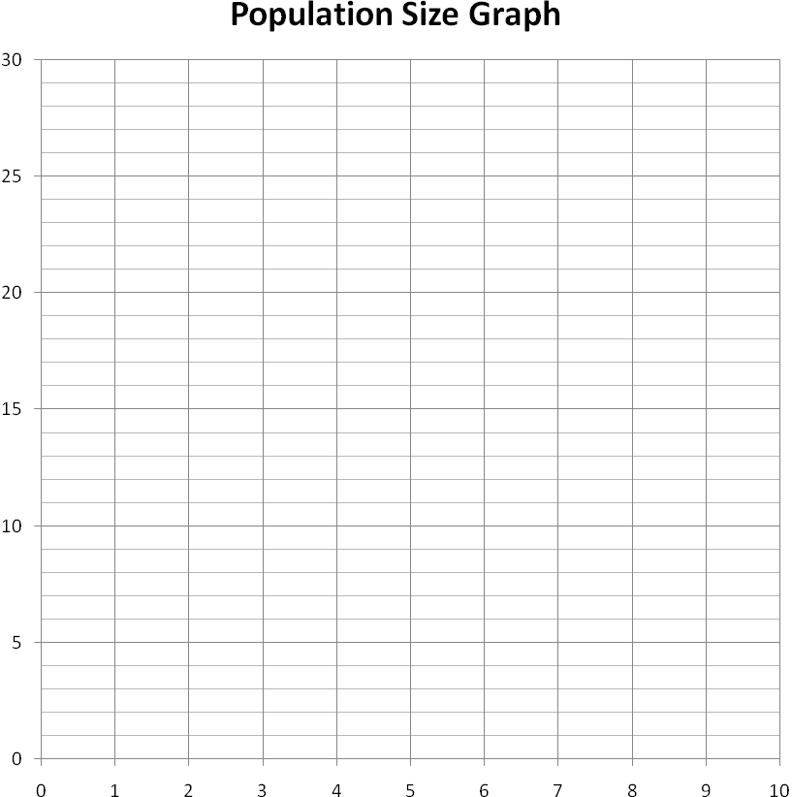
Number of Animals
Year

Year | Start (0) | 1 | 2 | 3 | 4 | 5 | 6 | 7 | 8 | 9 | 10
#

Forests Are Habitats!
Matching Cards and Animal Field Guides
- To make one Animal Field Guide:

If you are printing the pages off the CD or making copies from this guide:
- Print each page double-sided – follow the directions on your computer screen or copy machine. You should have pictures of animals on one side and pictures of shelters on the other. Make sure that you copy the page so that the text is right side up on both sides.
RIGHT!
WRONG!

- Cut out each box, leaving you with a double-sided guide for each animal.
- Each field guide lists the animal’s common, scientific, and Irish name, a basic description, and the typical diet of the animal.
- Note: Because these field guides are also used as matching cards, the names of the different animal shelters can’t be listed on the cards. If you are interested, the names are listed below. You can write these names onto your guides if you would like to share them with your students.

  - RED FOX = den
  - BADGER = badger sett
  - CROSSBILL = nest
  - OTTER = holt
  - FALLOW DEER = no name
  - RABBIT = warren
  - PINE MARTEN = nest
  - RED SQUIRREL = dreys

FOX – Vulpes vulpes - Sionnach  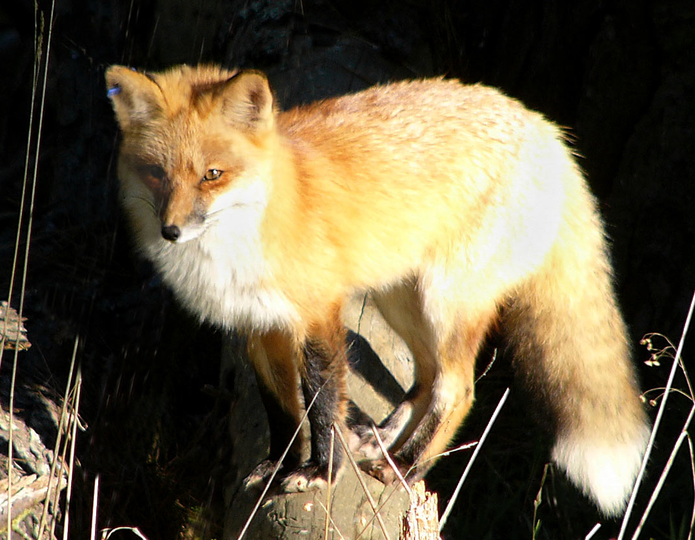  Description: Orange-red fur and bushy, white-tipped tail. Mostly out at night. Shy around people.  Diet: Mostly rabbits, small mammals, and birds, but some fungi and berries. | 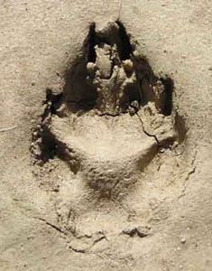  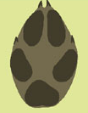
BADGER – Meles meles - Broc  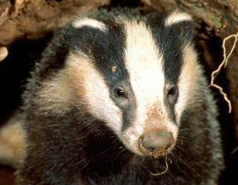  Description: Black-and-white facial stripes. Mostly out at night. They have large paws with inch-long claws used for digging for their favourite foods.  Diet: Slugs, earthworms, and sometimes berries. | 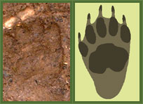
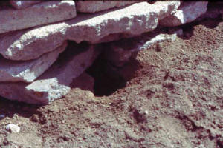

Description of shelter: A hole in the ground beneath rocks or tree roots.

