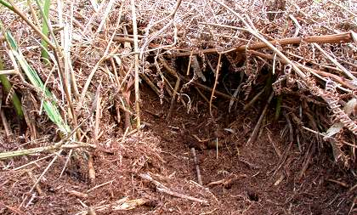

Description of shelter: Tunnelled holes in the ground, often under large boulders.
FALLOW DEER – Dama dama – Fia buí  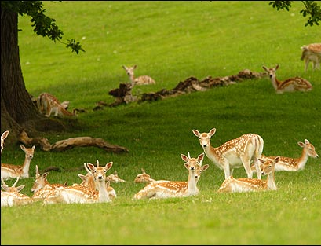  Description: Often times spotted. Males have antlers. Like to travel in herds.  Diet: A variety of grasses and herbs. | 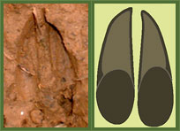
RABBIT – Oryctolagus cunniculus – Coinín  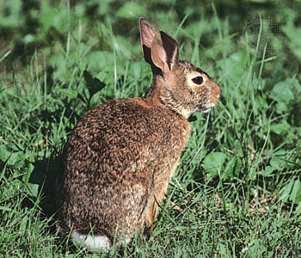  Description: Most commonly found from dawn to dusk. Legs are shorter than hares’. Puffy, white tail.  Diet: Most kinds of ground-level plants (including crops!). Especially fond of grasses. | Please note that the tracks of a rabbit’s back and front paws are different. Look for the pattern of the print with this animal!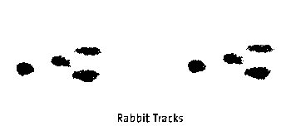  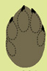
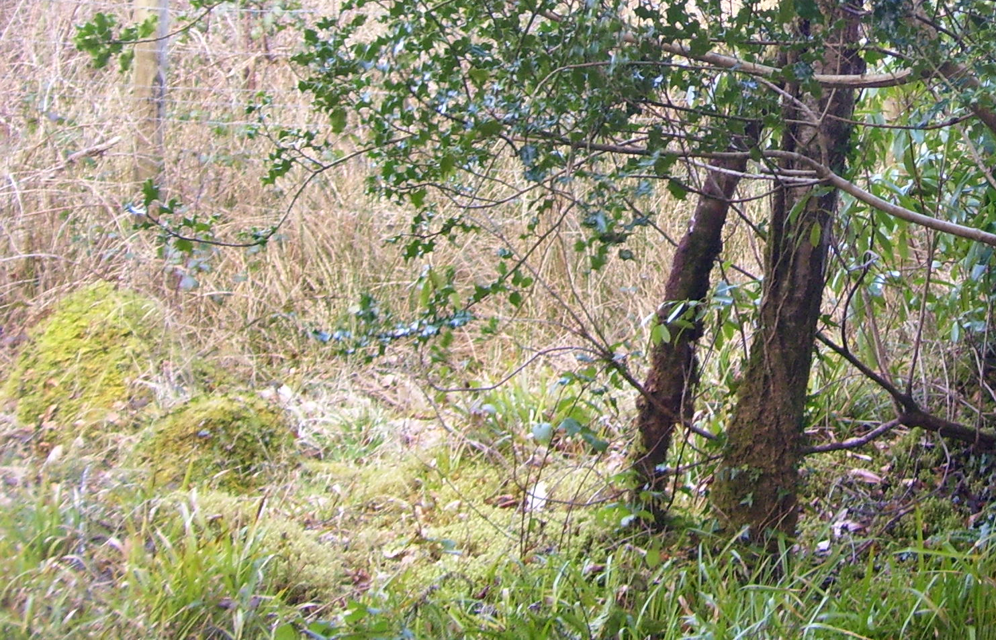

Description of shelter: These animals wander the forest and do not have
a day-to-day home, but they raise their young in a quiet spot in the forest.
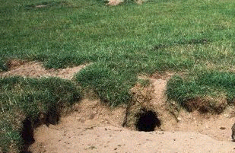

Description of shelter: Normally found in sandy areas, this shelter is a
network of underground tunnels that can sometimes cover acres.
PINE MARTEN – Martes martes – Cat crainn  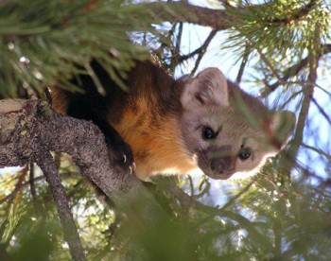  Description: Excellent climber who lives mostly in coniferous (evergreen) trees. Mostly reddish brown with a creamy chest and coat. Out at night.  Diet: Red squirrels and other small mammals, birds, insects, berries, and birds’ eggs. | 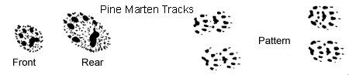  Front paw  Rear paw  Pattern

