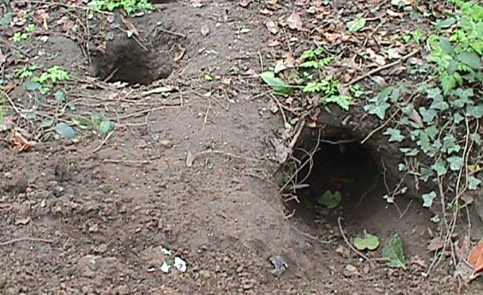

Description of shelter: An underground tunnel, connected to a network
of tunnels occupied by other animals of the same species.
CROSSBILL – Loxia recurvirostra - Ean  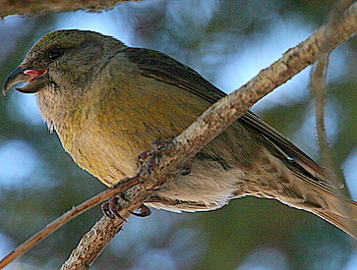  Description: Males are red, females are yellow. Bill is crossed to make prying seeds from cones easier. Usually flies in single-species flocks.  Diet: Seeds from conifers (evergreen cones). It likes spruce cones the best! | ← FEMALE  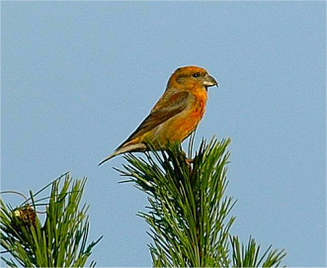  MALE  Close-up of beak  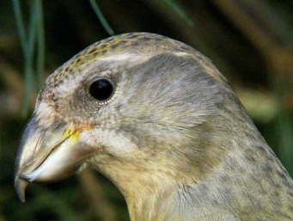
OTTER – Lutra lutra – Dobhrán or Madra uisce  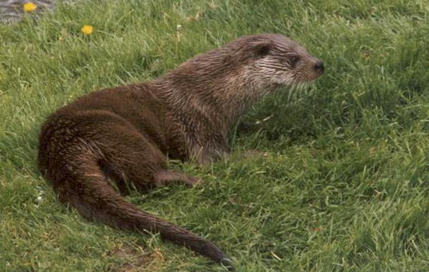  Description: Brown with a whitish underbelly. Lives on the land and in the water. Can dive underwater for several minutes at a time. Can be up to 5 feet long, including their tails.  Diet: Fish, eels, frogs, small mammals, and birds. | 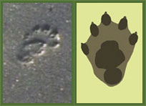
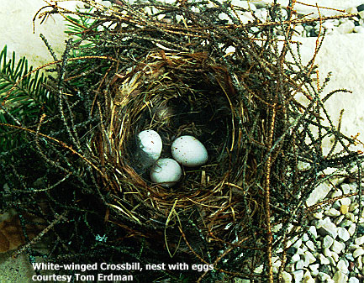

Description of shelter: Located high in conifers, on a horizontal
branch, among a cluster of twigs and overhanging vegetation,
in order to hide and protect it.

