Before You Get Started

When you arrive at the Tourmakeady Woods parking lot, it is a VERY good idea to set some ground rules for your students. Depending on your students, it may be more effective to have them brainstorm their own list of rules (with some prompting for you). Here are some recommendations:
- Stay behind Mrs./Mr._______ at ALL times. (S)he is the leader – you may not go in front of him/her!
- Stay in front of Mrs./Mr. ________ at ALL times. You may not lag behind him/her.
- Stay on the trail at all times – if you step off the trail, you might get hurt OR you might destroy some animal’s food or habitat!
- Leave only footprints, take only memories. Do not leave rubbish on the trails, and do not take ANYTHING from the forest. Let’s make sure we leave this place looking the same so that others may enjoy it in the future.
- Don’t PICK anything! If you pick a leaf off of a plant, that’s like someone coming to your house and stealing food out of your refrigerator - the plants can’t make their food without their leaves!
Where to Go

- When leaving the community centre, turn left out of the car park. You will drive down the road for just a few minutes before reaching the entrance to the Tourmakeady Woods.
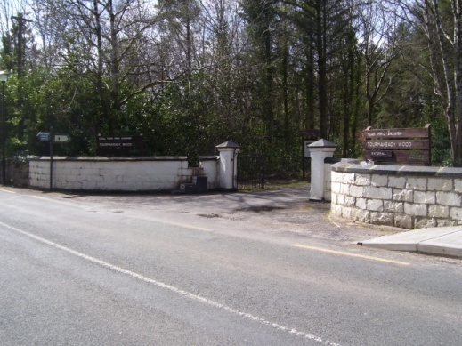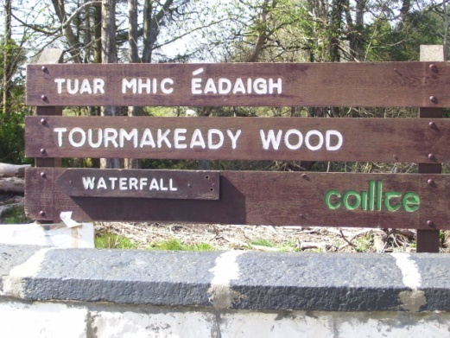
- Once you reach the entrance, drive down the road. You will pass a privately-owned house and eventually reach a car park on the left side of the road.

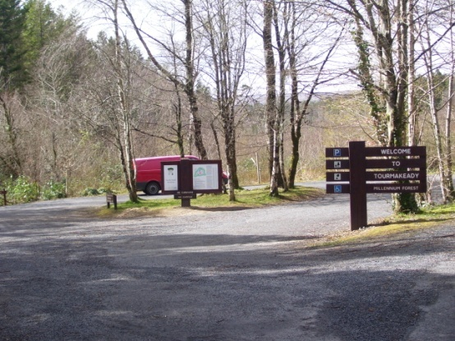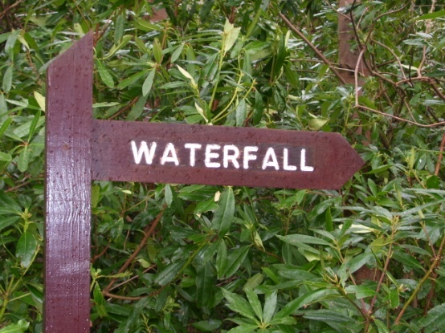

- The trail on the left side of the car park (the one that leads to the waterfall) is the trail that you want to walk on.

Map of the Tourmakeady Woods
This is a map of the trail in the Tourmakeady Wood with key stops labelled – for teacher reference! Look for the numbers on posts on the RIGHT side of the trail if you’re walking towards the waterfall.
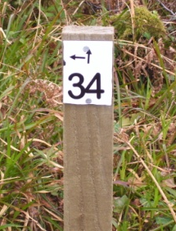
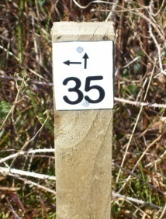
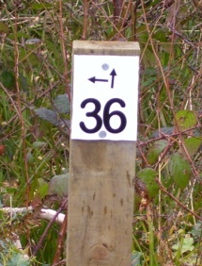

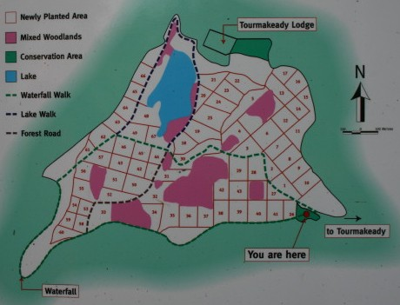
Car Park
Waterfall
34
35
36
= route for the Tourmakeady Educational Programme, Exploring Habitats!

Curricular Objectives
The following curricular objectives are achieved when this programme is completed in its entirety.
Subject | Strand | Strand Units
English |  | - Oral  - Reading  - Writing
Gaeilge | Éisteact | - Ag cothú spéise  - Ag tuiscint teanga
Gaeilge | Labhairt | - Ag cothú spéise  - Ag úsáid teanga
Gaeilge | Léitheoireacht | - Ag cothú fonn léitheoireachta  - Agúsáid teanga
Gaeilge | Na téamaí | - Caitheamh aimsire  - Ócáidí speisialta
Geography | Human environments | - Natural environmental features and people  - County, regional and national centres
Geography | Natural environments | - The local and natural environment
Geography | Environmental awareness and care | - Environmental awareness  - Caring for the environment
Maths | Data | - Representing and interpreting data
Physical Education | Games | - Creating and playing games
Physical Education | Outdoor and adventure activities | - Walking, cycling and camping activities  - Outdoor challenges  - Understanding and appreciation of outdoor and adventure activities
Science | Living things | - Plant and animal life
Science | Environmental awareness and care | - Environmental awareness  - Science and the environment  - Caring for the environment
What Is a Habitat?

Relevant background information: Habitat p.53, Populations p.54, Lough Mask p.52, Glensaul River p.53

Teacher materials: Population Size Graph – p.27, to be filled out as game is played

Student materials: Population Size Graph – p.27, pencils, clipboards if outdoors

Location: At the Community Centre

Approximate length of time for this activity: 30 minutes (including graphing activity)

Learning objectives:
- Students will be able to list the three primary features of habitat: shelter, food, and water.
- Students will see an example of how population size is affected by habitat.
- Optional: Students will learn basic graphing skills.

Brain-starters

- What does any living thing need to survive?
  - Prompt them to mention shelter, food, and water.
- What happens if a living thing does not have access to shelter, food, and water?
  - It dies or it moves to a place where it CAN find shelter, food, and water.

Activity Instructions

- Let students know that they’re going to play a fun game to learn about animals and habitat.
- Split students into two teams. Move the teams about 10m apart. Have the teams form single-file lines, then turn to face one another. One team will be the habitat – this team will not move. The other will be the rabbits. Note: You can have your class pick any forest animal – they don’t have to be rabbits!
- Teach your students three motions representing the three features of habitat. Have them practice making these motions (“signs”) along with you. Some suggested signs are below:
FOOD  Rub your tummy | WATER  Drink from a cup | SHELTER  Put a roof over your head

- Explain the rules of the game.
  - Students start out with their backs toward one another.
  - The teacher tells students to “make their symbol.” Students on BOTH teams then make the shelter, food, or water sign.
  - The teacher says, “1, 2, 3, SHOW YOUR SIGN!” Both teams then face one another.
  - The rabbits will then run to the habitat (habitat students do not move!) and tag someone from the habitat team who is making the sign that matches theirs. For example, a rabbit making the water sign will run over to the habitat and tag a habitat student making the water sign. Their signs must match!
HABITAT
RABBITS

  - If a rabbit tags a habitat student with the same sign, then they both travel back to join the rabbit team.
  - If a rabbit cannot find what it’s looking for in its habitat (food, water, or shelter), then it “dies” just like it does in the wild. And, just like in the wild, the rabbit will decompose, become a part of the Earth again, and join the habitat team. Note: This means that if a rabbit doesn’t find a partner, they’re still in the game, they’re just on the other team! There’s no reason to cheat!!
- Have the students count the number of rabbits after every round. Record the number they tell you on the provided worksheet.
- Have students play several rounds. For a class of about 30, 10 rounds is a good number to see how the population size changes based on what’s available in the habitat. You can tell students that each round is like a “year” for the rabbits.
- Optional graphing activity starts here. After the students have played 10 rounds, give them clipboards and the worksheet entitled “Population Size Graph.”
- Read the students the number of “rabbits” that survived each year so they can fill in the table at the bottom of the page.
- Have students plot the number of rabbits for each year on the graph, and then connect the points with a line.

Key Questions
- Check your group’s graph before you ask the first two questions!
- Looking at your graph, what happened after your biggest increase?
  - The biggest drop happened. This is called a population crash.
- What happened 9 or 10 years after the rabbit population was established?
  - The population started to level off and fewer rabbits survived or died from year to year.
- What happened when there weren’t very many rabbits?
  - There was plenty of habitat available – almost no rabbits died.
- What happened when there weren’t very many people on the habitat team?
  - A lot of rabbits died. That’s because rabbits depend on their habitat.
Forests Are Habitats!
Relevant background information: Habitat p.53, Tourmakeady Woods p.51, Forests p.54

Teacher materials: Animal Field Guides p.27

Student materials: 2 sets of Matching Cards p.27

Location: At the entrance to the Waterfall Trail. When you enter the parking lot, the trail is to your left with a yellow and black gate blocking vehicular traffic.

Approximate length of time for this activity: <10 minutes

Learning objectives

- Students will learn that habitats can be found anywhere.
- Students will learn that forests are an example of habitats.
- Students will be able to name eight animals that live in the forest, and describe their homes.

Brain-starters

- Remind me – what are the three things that make up habitat that every animal needs to survive?
- So, where can you find habitat?
  - Call on students and have them name different habitats – lake, desert, ocean, etc.
  - Most students will not say “cities” are habitats, but remind them about squirrels and birds.
- Forests are a kind of habitat, too, right? What animals do you think live in the forest? What do you think their shelters look like?

Activity Instructions

- Split the students into two groups. These are not competitive teams; it’s just so that everyone can see. Put an adult with each group to supervise and make sure that everyone is included.
- Pass out one set of Matching Cards to each group. The Matching Cards are the same as the Animal Field Guides, except the Animal Field Guides are back-to-back (you answer key!).
- Go through the pictures of the animals and make sure that they can name every animal. Make sure they know that all of these animals live in the Tourmakeady Wood.
- Have the students try to match the shelter to the animal.
- Check the students’ matches by having each group take turns holding up a set of matched cards.

Key Questions
- What are some things that these homes have in common?
  - Ex: A lot are made of grass, leaves, mud.
- What are some things that are different?
  - Ex: Size, location (on the ground or high up in a tree), how long it would take to make.
- Why are some things different?
  - Animals have different needs. Habitats must be suited to the animals living in them.
Using Field Guides
Relevant background information: Tourmakeady Wood p.51, Forests p.54, Habitat p.53

Teacher materials: If available, large tree guide from the Tourmakeady Community Centre

Student materials: Using Field Guides Worksheets p.37, clipboards, pencils, Tree Guides p.39

Location: Start at the entrance to the wood. Finish at marker 36 (found on the right side of the trail when walking towards the waterfall).

Approximate length of time for this activity: ~25 minutes, including walking time

Learning objectives

- Students will be able to identify important features of trees used for determining trees’ species.
- Students will be able to use a field guide.
- Students will learn more about forest habitats.
- Students will identify at least three different kinds of trees or shrubs.

Brain-starters
- So, now we’ve seen that trees are really important in a forest habitat. We’ve also seen that different animals need different things from their habitats. Do you think that maybe there are a lot of different trees and plants in a forest that has so many different animals in it?
- Do you know the name of every tree in that forest? ME NEITHER!! I do know how to find out their names, though. Do any of you know what a field guide is?
  - A tree field guide is a kind of reference book that you use to learn the names of different trees.
  - If you know certain facts about a tree (like the colour and shape of its leaves), a field guide can help you identify it.
  - A tree field guide will also give you extra facts about the tree, like its average height and how it changes through the seasons.
  - Make sure students know that there are LOTS of different field guides to help you identify and learn about different things.
- Have any of you ever used a field guide before?
  - If students have a field guide before, ask what kind of field guide they used. What were they looking for? Birds? Other animals? Mushrooms?
  - Tell the students who have used field guides that they’ll have to help you teach everyone else.
- Do you think that different forests in different places have different trees, plants and animals?
  - YES! Think about the rainforest versus this forest. We’re in luck because we have field guides specifically for the Tourmakeady Woods! But first we have to find the right information so that we can use the guides properly.

Activity Instructions:

- Pass out three Using Field Guides worksheets to each student.
- Tell students that they need to find three different trees or shrubs and fill out the information on the worksheets – one for each tree or shrub.
- Walk students through the process of filling out the worksheet (see worksheet). Ask if there are any questions.
- Remind students NOT TO PICK ANYTHING.
- Tell students that they will be walking very slowly through the woods so they can look around. When they want to stop to draw something or fill out their worksheets, they may do that so long as they stay in front of Mr./Mrs. ____ and behind Mr./Mrs. _____.
- When you reach marker 36, have students stop. Make sure that all of them have completed their worksheets. If they haven’t, give them a few minutes to finish them.
- Have the students break into groups of two or three. Give each small group a tree field guide (provided in this guidebook).
- Have the students work together, using the information on their worksheets, to identify at least three trees or shrubs amongst them. They should write the name into the top of the worksheet.
- Note: It’s very possible that the students may have found something that isn’t in the field guides. If they can’t identify their tree or shrub, have them look in a “big” field guide that you have with you (provided) or when you get back to the community centre.

Key Questions

- Was it hard to find the information on the worksheets?
  - Some of the information (like the seeds) may have been hard to find, but others were REALLY easy, like the colour of the leaves or flowers.
  - Field guides are useful because they help you use lots of different easy-to-find bits of information to find out something you don’t know – the name of a tree or shrub, for example!
- Which tree did the most people find?
- Do you feel like you could use a bigger field guide now that you understand how they work?
  - I KNOW YOU CAN!

Note: Walk the rest of the way to the waterfall after this lesson, letting students use the Tree Guides.

Waterfall Sketches

Relevant background information: Glensaul River p.53, Lough Mask p.52, Habitat p.53

Teacher materials: Look at http://www.school-portal.co.uk/GroupDownloadFile.asp?file=21604 before the trip if you can.

Student materials: Clipboards, blank pages for drawing (a few per student), pencils

Location: At the waterfall.

Approximate length of time for this activity: ~20 minutes

Learning objectives
- Students will be able to locate the hard and soft rock in a waterfall.
- Students will draw water in two different settings.

Brain-starters

- We know that water is an important part of habitat. What are some different uses for water?
- Plants use it to grow, animals drink it, plants and animals live in it (fish, crabs, insects, etc.)
  - It carves away rock and shapes the ground. Have them note how smooth a lot of the rocks are and how steep the river bank is in some places.

Activity Instructions

- Explain waterfall formation to students. The animation at http://www.school-portal.co.uk/GroupDownloadFile.asp?file=21604 is very helpful if you can review it beforehand.
  - Hundreds of years ago, there was a slope where that waterfall is now.
  - As the river flowed down the slope, it wore away the softer rock it flowed over.
  - There was a layer of really hard rock at the top of the waterfall. It was not worn away very easily.
  - After years and years, a “step” developed from one layer of rock to another. The softer rock was at the bottom of the step, and the harder rock was at the top. The water kept wearing away the softer layer until the step got taller and taller.
  - Eventually, the distance between the hard rock and the bottom of the “step” got to be REALLY big, and that’s why the waterfall’s so tall. Remember, there’s hard rock at the top of the waterfall, and soft rock at the bottom.
- Pass out paper to all of your students – give each of them a few sheets.
- Have them find a comfortable place to sit down and tell them that for the next 10 minutes they can sketch anything related to water that they want.
- When students have finished their drawings, have them share their art in small groups.

Key Questions

- What did people sketch the most?
- Did anyone manage to draw hard and soft rock in their pictures? Can we see?
Animal Food Search

Relevant background information: Habitats p.53, Forests p.54, Food Chains p.54

Teacher materials: None

Student materials: Animal Food Search Worksheet p.47, clipboards, pencils

Location: Between the Waterfall and Marker 34.

Approximate length of time for this activity: ~15 minutes

Learning objectives

- Students will be able to name the foods that at least one forest animal eats.
- Students will work in groups to identify plants, insects, and cones.
- Students will keep count of plants, insects, or cones using tally marks.
- Students will practice good teamwork skills.
Brain-starters

- So, we’ve talked about shelter and water. What is the third part of habitat?
- What kinds of things do you think animals in a forest habitat eat?

Activity Instructions

- Split your group into three teams: the Rabbits, the Badgers, and the Crossbills. They’re going to pretend to be those animals!
- Give each group an Animal Food Search worksheet. Have the group pick a recorder.
- Talk to your students about how to keep a running tally. Tell them they’re going to keep a tally of the food they find.
- Have students look at the Animal Guide for their animal to figure out what kind of food the animal eats. Then, have them record that food on their worksheet.
- Explain to students that they’re going to pretend to be rabbits, badgers, or crossbills and it’s their job to find plenty of food. THEY MUST TRAVEL IN A GROUP. As they find a plant, cone, or insect (depending on what animal they are representing) they should mark their worksheet.
- Explain that there are TWO tricky aspects to this Animal Food Search:
  - At every site they find, they have to PRETEND to eat what they have found. They can’t just spot the food and keep running.
  - Rabbits, badgers, and crossbills are very shy of people. There will be a teacher or parent at the front of the group “on a walk,” and a teacher or parent at the back of the group “on a walk.” THE STUDENTS MUST STAY BETWEEN THEM. Note: This rule keeps people moving, but stops them from running ahead. This way, the teachers set the pace – don’t go too fast!
- Remind students to stay on the trail as much as possible and to avoid trampling anything.
- Give the teacher taking the lead a minute’s head start down the trail – remind him or her to stop at Marker 34. Have the rest of the students wait by the waterfall.
- After a minute has passed, send the students off on their “Animal Food Search.”
- Once you reach Marker 34, make sure all pencils are stopped and that all of your students have arrived safely.

Key Questions

- How did the badgers do?
  - Ask them to read off their tally.
  - The badgers had to stop to dig a hole or look under logs, which is hard to do when you’re avoiding people and predators. Perhaps this is why badgers are mostly nocturnal and very shy around people.
- How did the rabbits do?
  - The rabbits probably found food everywhere, but had trouble “eating” fast enough to stay ahead of the teacher bringing up the rear.
  - Have students think about how MUCH food rabbits have to eat, too.
    - Which is more filling? A hamburger (like an insect) or a salad (like the plants)?
    - Rabbits have to eat more to get the same amount of energy as a badger gets from eating an insect.
- How did the crossbills do?
  - The crossbills probably only found food at certain points along the trail (where coniferous trees were found). This was probably hard as people (or predators) were approaching, because maybe there was LOADS of food available at one spot, but they couldn’t get to it after a certain point because it was too “dangerous.”
- What did all three groups have in common?
- Do you think finding food is hard work?
  - Humans are lucky to have grocery stores!

Trees Need Habitat, Too!
Relevant background information: Forests p.54, Tourmakeady Woods p.51, Food Chains p.54, Habitat p.53

Teacher materials: Script for this activity.

Student materials: None.

Location: At Marker 34.

Approximate length of time for this activity: ~10 minutes.

Learning objectives

- Students will be able to identify the functions of several different parts of a tree.

Brain-starters

- When we talked about habitat earlier, we said that ALL LIVING THINGS need habitat. Does that mean just animals?
  - No, trees need habitat, too!
- But trees can’t hunt down water, can’t eat, can’t dive into a nest for shelter…they have to stay still!
  - Most people don’t recognise just how much trees do – even if we can’t see it!

Activity Instructions

Some basic guidelines for this activity:
- It’s meant to be kind of silly, but they’ll learn, too!
- Select a few students at a time to come up and join the tree you’re “building.”
- Have all of the students repeat the name of each part of the tree after you, and make sure the students that you pick remember what they are supposed to represent.
- Every time you add a layer of the tree, have that layer practice their moves and words ONCE, then go back to the beginning and let each layer practice their moves and words again.
- DO NOT have them continue their moves and words as you’re explaining everything – it will get too loud and distracting.
- Follow the script below to guide you through the activity.
- Choose 1 big, strong student. This student will be the heartwood.
  - Read: “The heartwood is the inner core of the tree – it is what keeps the trunk standing up straight. You used to be alive, but over the years, you died – you still have an important job, though.”
  - Have the student show his/her arm muscles, showing everyone how strong he or she is.

- Choose a few people who will be willing to sit on the ground. These students are the taproots.
  - Read: “The taproots get water from deep in the ground and anchor the tree in place.”
  - Have the students sit down with their backs to the heartwood, forming a circle around the heartwood. Have them make slurping noises, like they’re sucking water up from the ground.
- Choose a few more people who will be willing to lie on the ground. These students will be the lateral roots.
  - Read: “The lateral roots grow outwards to get water and nutrients from the soil. There are usually hundreds of lateral roots on a tree.”
  - Have the students lay down on their backs with their feet towards the heartwood, forming another circle around the taproots. Have these students slurp as well.

- Choose enough people to form a complete circle around the heartwood, standing in between the taproots and lateral roots. These students will be the sapwood.
  - Read: “The sapwood pumps water up to the branches of the tree.”
  - Have the students pretend they’re holding a cup, and scoop up water from the roots. Later, they’ll pass that water on to the branches (once they’re added).

- Choose enough people to make a circle around the sapwood. These students are the phloem.
  - Read: “The phloem (flow-em) carries food down from the branches and leaves to the rest of the tree.”
  - Have the students say, “We move food!”

- Choose all but a few of the remaining students to form another circle around the phloem. These students will be the bark.
  - Read: “The bark protects the tree from insects, fungi, and pests. It also keeps the tree from drying out. If people pull you away from the tree, the tree can get very sick. It’s like when people scrape their knees, except they can put a plaster over the scrape so that it doesn’t get infected. There are no plasters for trees – just you, the bark!”
  - Have the students face out, cross their arms, and put on a mean face like a bodyguard.

- Have the remaining students pick spots around the “tree.” They are the branches and leaves.
  - Read: “Branches hold the leaves high up to the sky so they can get sunlight. The leaves then use the sunlight to make food for the tree.”
  - Have them hold out their arms high to the sky (like branches) and say, “We make food!”

- Now that you have built your tree, have all of the students do their part at the same time! Give them three big cheers!

Key Questions

- OK, so how do trees find their food?
  - The leaves make it, then the phloem carries it throughout the tree.
- And how do trees find their water?
  - The roots suck it up and it gets carried through the tree by the sapwood.
- And what is a tree’s shelter?
  - Its protection is its bark – it makes its own!
- Do trees need things from the environment, though, or can they do everything themselves?
  - They still need water and nutrients, plenty of sunlight, and a safe space to grow in – they have habitat, too!
What is a Habitat? Revisited

Relevant background information: Habitat p.53, People Need Habitat, Too! p.55

Teacher materials: The background information will be very useful for you in this activity.

Student materials: Do People Need Habitat? Worksheet p.48 , pencils, clipboards if outdoors

Location: Community Centre

Approximate length of time for this activity: ~10 minutes

Learning objectives
- Students will list the three features of habitat: food, water, and shelter.
- Students will list at least three human needs from the environment involving food, water, and shelter.
- Students will recognise that the environment makes up a habitat for humans, too.

Brain-starters

- So, remind me ONE MORE TIME – what are the THREE THINGS that make up every habitat?
- And does EVERY living thing need habitat?
- People are living things, right? Let’s think about that some more.

Activity Instructions

- Have students break out into small groups at the tables.
- Give each group a Do People Need Habitat? Worksheet. Give them 5 minutes to work together to brainstorm lists of food, water, and shelter-related human needs from the environment.
- Have the groups share their lists with each other.
- Talk about some of the human connections to the environment in Tourmakeady (see Background Information) or in your home community.

Key Questions

- So, do people depend on the environment to survive?
- How is our habitat different from other animals’?
  - We get our environmental resources from far away sometimes (like water getting piped from Lough Mask to our communities or lumber for houses coming from another country), but animals can only find their habitat as far away as they can walk or fly!
- Since we need habitat, and that habitat is found in the environment, we should try to keep the environment as nice and clean as we can. What are some things that we can do to keep the environment safe?
  - Make less rubbish by asking yourself, “Is this REALLY rubbish, or can I use it again?”
  - If there is no other use for your rubbish, make sure you recycle it if you can.
  - Use a lunchbox instead of plastic lunch baggies – you can reuse a lunchbox!
  - Help clean up your village or community – if you see rubbish, pick it up!
- If we do these things to protect our own habitat, we’ll be protecting other animals’ habitats, too! (Make sure to mention habitat since this is the last thing students hear!)

Rainy Day Options
Exploring the outdoors with your students has SO many benefits for both you and your students. However, there are some risks associated – the weather is very unpredictable! Most of the activities compiled here are intended to take place outdoors. If there is a light rain, it is highly recommended that you bring your students out anyway – they should have come in the appropriate attire, and a little dampness won’t hurt them. It’s an authentic experience.
However, if the weather is such that it will have a negative impact on the students’ experience, here are some options for how to bring some of these activities indoors to the community centre.
What is a Habitat?
This game is easily played indoors in the main hall of the community centre.
Forests are Habitats!
This activity is easily facilitated indoors.
Using Field Guides
The community centre has “Leaf Boards” with pressed leaves and pictures of trees on them with no names associated. These are available upon request. Have students fill out eight worksheets using the eight boards, and then use the Tree Guides to identify each plant BASED ON THEIR WORKSHEETS.
Waterfall Sketches
There are several laminated pictures of the waterfall and surrounding areas at the community centre. These are available upon request.
Trees Need Habitat, Too!
This activity is easily facilitated indoors.
Also, consider the forecast for the DAY when you make your decisions. If there’s a chance of rain later in the day, get all of the activities that you want to do outside done FIRST.
Must be done first: | What is a Habitat? (OK Indoors)
To be done in any order: | Best Outdoors | OK Indoors
 | Using Field Guides | Forests are Habitats!
 | Waterfall Sketches | Trees are Habitats, Too!
 | Animal Food Search
Must be done last: | What is a Habitat? Revisited (OK Indoors)

Classroom Options
The concepts explored in these lessons lend themselves very well to further exploration in the classroom. You can find some basic suggestions below for activities to do in your classroom or near your school.
Content Area | Activity Ideas
English | - Letter writing (related to environmental issues)  - Invitations to friends to visit the Tourmakeady Woods  - Journals about the experience
Gaeilge | - Revisit Irish vocabulary from trip  - Record Irish vocabulary  - Discuss issues related to the Special Occasion  - Talk about Gaeltacht areas
Geography | - Mapping in schoolyard  - Mapping of what they saw/where they travelled
Maths | - Brainstorm what maths ideas were used
Physical Education | - Discuss what was learned
Visual Arts | - Paint, colour, draw, etc. based on what was seen on the trip in preparation for an Art Fair!

Assessment

- Thinking skills

  - Questioning
  - Observing
  - Predicting
  - Analysing
  - Recording and communicating
  - Applying and problem-solving
  - Integrating and connecting
  - Reasoning
  - Understanding and recalling
  - Evaluating

- Observation

- Teacher-designed tasks

  - Use tasks as per guide

- Portfolio

  - See worksheets in Materials section
Classroom Plans
You might want to plan out some of your own activities for before and after the programme related to each lesson. Feel free to use the template found below.
What is a Habitat?

Before:

After:

Forests are Habitats!

Before:

After:

Using Field Guides

Before:

After:

Waterfall Sketches

Before:

After:

Animal Food Search

Before:

After:

Trees Need Habitat, Too!

Before:

After:

What is a Habitat? Revisited

Before:

After:

