Tourmakeady Educational Programmes

The Tourmakeady Educational Programmes were launched in May 2008, in conjunction with the Tochar Valley Rural Community Network (TVRCN) and Michigan State University. This book is the product of a community-based education initiative.

Tourmakeady is truly an outstanding location for place-based educational programming. Aside from its rich history, it offers an abundance of natural resources including woodlands, rivers, lakes, mountains, waterfalls, and rolling hills. It is also a Gaeltacht region, meaning that there is strong local support for the use of the Irish language. The people of Tourmakeady recognise how fortunate they are to live in such a magnificent area, and the goal of their educational programmes is to share these resources with people throughout Ireland, especially youth from County Mayo. Many young people in this area may not recognise how wonderful the West of Ireland truly is. These programmes are not only needed to educate youth about their surroundings, but also to help instill in them a sense of pride in their own history, homeland, and heritage.

The TVRCN is a network of eighteen rural communities throughout County Mayo. The purpose of the Network is to help rural communities build and use their own strengths to reach community-defined goals. In this instance, TVRCN support was provided in the form of an intern from Michigan State University with expertise in community-based educational programme development and environmental science. The hope is that the TVRCN will be able to support other communities throughout County Mayo in similar endeavours, geared towards sharing the wonder of County Mayo’s culture, history, and natural resources with people throughout the local area and the world.

Exploring Habitats!

The focus of this one-day field trip is the exploration of the concept of “habitat” in a fun, engaging way. The main goal of this programme is to teach children that every living thing needs a habitat to survive. A habitat MUST include food, water, and shelter. While you can find habitats almost anywhere you go, students will explore a forest as an example.
This programme has many features that make it unique, exciting, and engaging.
- It takes place outdoors!

Students get to explore new sights, sounds, and smells. While there are some activities that can be facilitated indoors (considering the possibilities for foul weather), the main focus is getting students outdoors, exploring nature!
- It is hands-on!

The suggested lessons will keep students actively engaged throughout the entire day.
- It appeals to multiple learning styles!

People learn in lots of different ways. This programme is suitable for students who are visual, auditory, kinaesthetic, or verbal learners – there’s something for everyone!
- It meets curricular objectives!

Even though this programme takes place out of the classroom, that doesn’t mean that your students won’t still be working towards the goals they have in the classroom! Every suggested lesson meets several curricular objectives.
- It is teacher-led!

You know your students best – this programme lets you cater to their needs! You can pick the lessons you and your students are most interested in, move at whatever pace you choose, and alter the lessons so that they work for YOU. It’s all up to you!
- It is community-supported!
The community of Tourmakeady works hard to make sure this is a great experience for you and your students. At the Tourmakeady Community Centre, you will find:
  - Toilets and an indoor classroom.
  - A friendly face to greet you and give an introduction to the programme and Tourmakeady.
  - Clipboards, pens, and pencils for students.
  - A copy of this book, some reference guides, and binoculars for teacher use.

How Do I Get My Students Involved?

This programme is recommended for groups with less than 30 students, accompanied by at least 2 adults. Due to seasonal changes in the forest, the months of operation are May, June, September, and October. The cost for participation in this programme is €75 per group for the full day. To sign up, ring Deirdre Cavanagh of the Tuar Mhic Éadaigh Coiste Pobail at 094 95 43991.

What Would We Need to Bring?
- Pack lunches
- Photocopies for your students
- Appropriate outdoor attire

  - Clothes and shoes that could get wet and mucky
  - Umbrellas or rain jackets in case of unpredictable weather
Directions to the Tourmakeady Community Centre

From Ballinrobe:
• Follow the N84 to Partry.
• At Partry, turn left at the Garda Station.
• For a short distance, follow the R330 and then take the second left turn.
• There is a sign here for Tourmakeady.
•This road is fairly winding until you cross a bridge.
•Continue along this road and eventually you will come to a T junction – here, you turn left.
•Stay on this road and you will arrive in Tourmakeady Village (see below).

From Castlebar:
• Follow the N84 to Partry.
• At Partry turn right at the Village Inn.
• For a short distance you fold the R336 and then take the second left turn.
• There is a sign here for Tourmakeady.
• This road is fairly winding until you cross a bridge.
• Continue along this road and eventually you will come to a T junction – here, you turn left.
• Stay on this road and you will arrive in Tourmakeady Village (see below).

From Westport:
• Follow the R330 along a rugged and open road and continue for some time on to Killawalla and the village of Killavally with a public house and a small petrol station.
• At some point, you will see a sign for Partry Community Alert, then a finger sign for Derrigdafderg.
• Passing these signs, you continue on R330 and you will come to a signpost for Tourmakeady 8 km L. Mask Drive.
• Turn right here. Stay on this road for approximately 8 km and you will arrive in Tourmakeady Village.

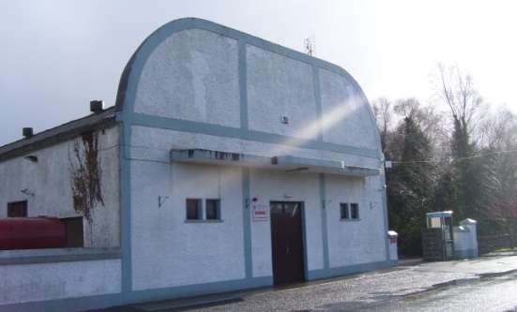
From Tourmakeady Village:
• You will pass the GAA Football Pitch and Car Park and the Lough Mask Inn Public House. Just past the pub, there is a small grotto, and here you should keep to the right at the shrine.
• You will then pass another Garda Station, and the Tourmakeady Community Centre is on the left.

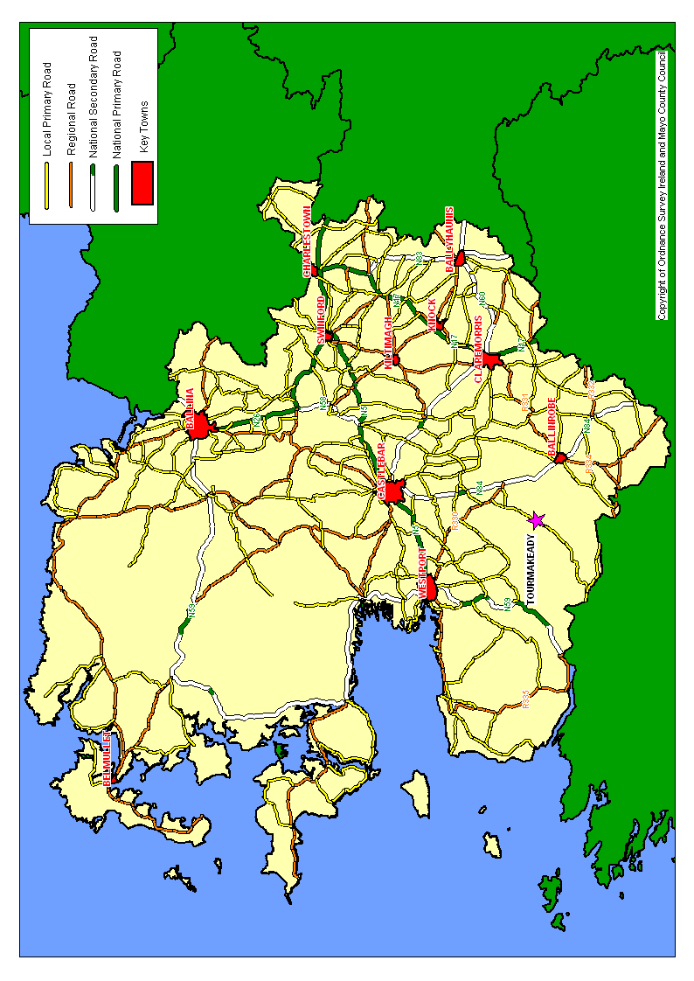

How to Use This Guide

This guide lays out everything that you need to help your students take part in this local, exciting, meaningful programme. All of these materials can be found in the printed booklet or on the accompanying CD.
- Lessons

These lessons are suitable for 3rd-6th class students. These lessons can be taught exactly as they are written, but we encourage you to adapt them to meet your needs and interests. Included within every lesson, you will find:

  - Relevant background information
This section directs you toward extra information that can be found at the back of this guide.

  - Teacher materials
This section tells you where in this guide lesson-specific teacher materials can be found.

  - Student materials
This section tells you where in this guide lesson-specific student materials can be found.

  - Location
There is a suggestion for where each lesson could be taught, but you’re welcome to choose another location if you find it more suitable.

  - Approximate length of time for this activity

  - Learning objectives

  - Brain-starters
In order to convey certain messages and get students’ brains working, there are some recommended questions you can ask before the start of the lesson.

  - Activity instructions
This section outlines exactly what you could do to teach the lesson, but you are encouraged to adapt these instructions however you see fit.

  - Key questions
In order to reinforce key messages, there are some questions you can ask to encourage student reflection and thought.

- Curricular objectives outlined
- Worksheets and handouts for students
- Reference guides (field guides) specific to the Tourmakeady Wood
- Easy-to-read background information about the lesson content and area
- Recommended resources if you want to find more information

Suggested Timeline

10:30 | Arrive at the Tourmakeady Community Centre  Unload bus and get situated in main hall.
10:45 | Introduction to Tourmakeady  Short presentation by Tourmakeady representative, including description of some local characteristics and history, and an explanation of Exploring Habitats to get your students excited about the day!
11:00 | What is A Habitat?  Play game in the community centre hall.
11:30 | Collect supplies, visit toilets, and leave Community Centre  Some supplies will be provided by Tourmakeady Community Centre.
11:40 | Rules  Set ground rules for the day.
11:45 | Forests Are Habitats!  Explain to students that a forest is a kind of habitat (at the edge of the trail).
11:55 | Field Guide Activity  Give students mini tree guides and checklists (at the edge of the trail).
12:20 | Arrive at the Waterfall  Eat lunch at this site, and possibly take a group picture.
12:55 | Waterfall Sketches  Have students draw the waterfall and/or river at the waterfall.
1:10 | Animal Food Search  Give students worksheets after leaving the waterfall and stop at Marker 34.
1:25 | Trees Need Habitat, Too!  Build a human tree at Marker 34 (about halfway) down the trail.
1:35 | Walk Back to Parking Lot  The parking lot is a great location for a group picture, too!
1:50 | Return to the Community Centre by bus
2:00 | What is a Habitat? Revisited  Discuss what was learned at the community centre.
2:15 | Return ALL supplies, and visit toilets again.  A Tourmakeady community member should be there to meet you.
2:30 | Depart for your school  Be sure to enjoy some local scenery on your way home, potentially stopping at the public lake access on your way out of town.

