Atlantic Rhythm Productions

present a new play

The Emigrant’s Farewell

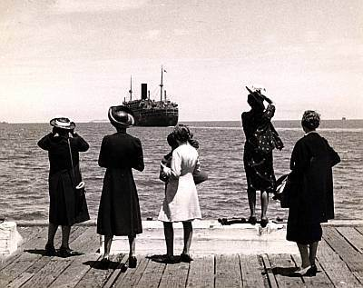

in Halla Tourmakeady
Tourmakeady

Saturday 2nd March 2013 @ 9pm

Tickets €10

For more information call 0871162058

